  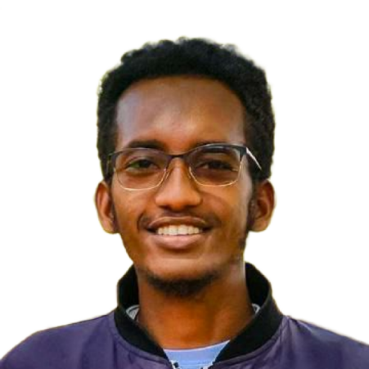
  Education
  Bachelor of Science in Computer Science
  [@Dilla University Ethiopia]
  - Currently in last year of university, preparing to graduate in 2027.
  - Focused on Software and full-stack web development and responsive UI/UX design.
  - Relevant coursework: Data Structures & Algorithms, Web Development, Database Systems, Software Engineering.
  - Academic projects include AI-powered applications, responsive websites, and scalable Git workflows
  Key Skills
  Software and Web Development
  Version Control & Deployment
  Programming
  Project Organization
  Design & Branding
  Problem Solving & Troubleshooting
  Hobbies & Interests
  - Socializing with friends
  - Travelling
  - Reading
  - Classic films
  - Learning new languages
  Tesfatseyon Merkineh
  Full Stack Web developer
   | +251 983708869  +251 950030794 |  |  | Wolaita-Sodo, South Ethiopia region, Ethiopia
   | Tesfasteyon16@email.com |  |  | linkedIn.com/in/tesfatseyonmerkinh
  Profile
  Freelance Software and Full-stack Web Developer also Graduate class Computer Science student (graduating 2027) with hands-on experience in building responsive websites and scalable project structures. Skilled in Git workflows, React, Python, and modern UI/UX design, with a focus on clean, modular code and professional branding. Detail-oriented and persistent in troubleshooting, adaptable to new technologies, and passionate about creating youth-friendly, modern digital experiences.
  Professional Experience
  May 2023 – Aug 2023  Hotel Design Website |  | Frontend Developer  - Built and deployed a responsive hotel design site with modern UI layouts and compact folder structure.  - Improved responsiveness and cross-device compatibility, enhancing user experience.
  Sep 2023 – Dec 2023  Fellowship Website |  | Frontend Developer  - Developed a responsive Christian student’s fellowship website for Dilla University EvaSUE, integrating worship schedules, ministry programs, and image galleries.
  Jan 2024 – Apr 2024  AI for FOREX Analayzing |  | AI/ML Developer  Independent Project  - Created an AI-powered system for analyzing and predicting FOREX market trends using Python, scikit-learn, pandas, and matplotlib.
  May 2024 – Present  Amharic offline-Chat AI |  | Developer  Independent Project  - Designed and implemented an offline Amharic language assistant using Python and JavaScript.  - Integrated natural language interaction in Amharic, expanding accessibility for local users.

